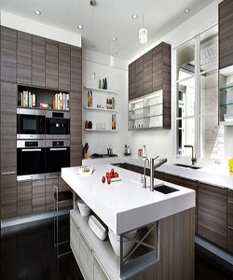

Modern Kitchen Cabinet

$212.67

Availability: In stock

Description

Modern, Simple and clean lines wood cabinets. . Glossy white tabletop cabinets. Matte wood brown door, soft close hinges, drawer boxes and lifting mechanisms. Full assembly instructions are included in the box, certified for the highest quality.